

Mathematics Selected Key Texts – White Rose Maths
Scheme of Work Phase | Featured Texts
Phase 1 – Just Like Me | 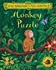  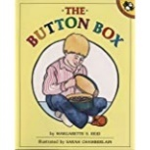  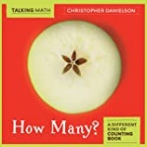  Monkey Puzzle by Julia Donaldson  The Button Box by Margarette S Reid  How Many? By Christopher Danielson
Phase 2 – It’s Me – 1, 2, 3! | 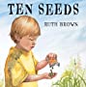  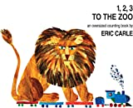  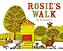  Ten Seeds by Ruth Brown  1 2 3 to the Zoo by Eric Carle  Rosie’s Walk by Pat Hutchins
Phase 3 – Light and Dark | 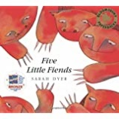  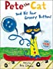  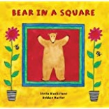  Bear in a Square by Stella Blackstone and Debbie Harter  Pete the Cat and his 4 Groovy Buttons by Eric Litwin  5 Little Friends by Sarah Dyer
Phase 4 – Alive in 5! | 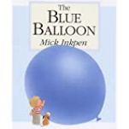  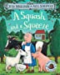  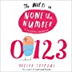  The Blue Balloon by Mick Inkpen  A Squash and a Squeeze by Julia Donaldson  None the Numbers by Oliver Jeffers
Phase 5 – Growing 6, 7, 8 | 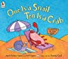  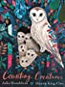  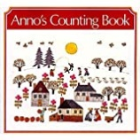  One is a Snail Ten is a Crab by April Pulley Sayre  Anno’s Counting Book by Mitsumasa Anno  Counting Creatures by Julia Donaldson
Phase 6 - Building 9 & 10 | 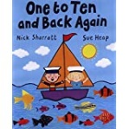  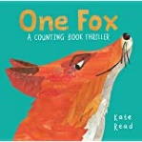  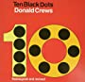  Ten Black Dots by Donald Crews  One Fox : A Counting Book Thriller by Katie Read  One to Ten and Back Again by Nick Sharratt and Sue Heap
Phase 7 – To 20 and beyond | 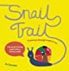  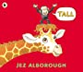  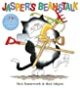  Tall by Jez Alborough  Jasper’s Beanstalk – by Nick Butterworth  Snail Trail: A Journey through Modern Masterpiece by Jo Saxton
Phase 8 – First, then, now | 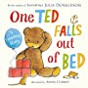  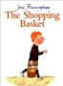  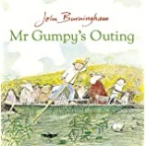  The Shopping Basket by John Burningham  Mr Grumpy’s Outing by John Burningham  One Ted Falls Out of Bed by Julia Donaldson
Phase 9 – Find my pattern | 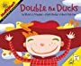  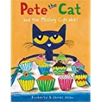  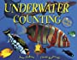  Double the Ducks by Stuart J Murphy  Pete the Cat and the Missing Cupcakes by Kimberly and James Dean  Underwater Counting By Jerry Pallota
Phase 10 -On the move | 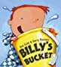  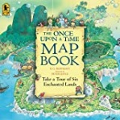  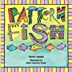  Billy’s Bucket by Kes Gray and Garry Parsons  Once Upon a Time Map Book by B.G. Hennessy  Pattern Fish by Trudy Harris

Autumn Term
Spring Term
Summer Term

