 | EYFS Autumn Term  ‘Marvelous Me’  Discovering… |  |  | 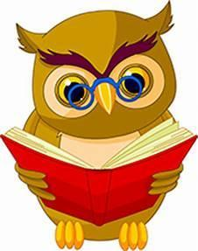
Autumn 1 Super 6 Books
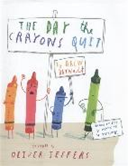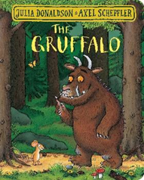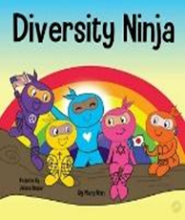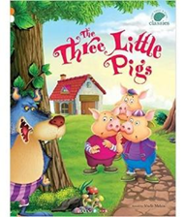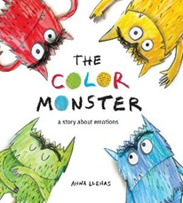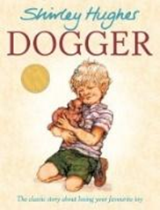

Autumn 2 Super 6 Books

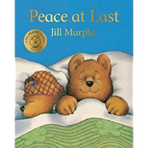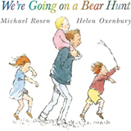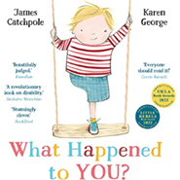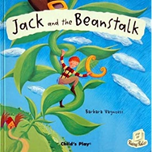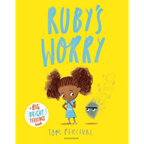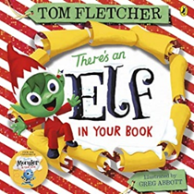
Our Super 6 books change every half term. They are carefully selected by the staff to cover a range of genres and themes. We hope that the 36 books that they read over the year during ‘Pledge’ time will become some of their treasured childhood favourites. We think your children will love them just as much as we do!
Maths  We follow the White Rose Maths programme in school and this term we will be covering the units:  - Match, Sort and Compare  - Measure and Patterns  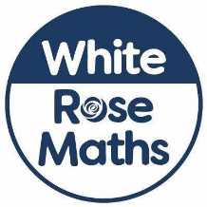  - It’s me 123  - Circles and Triangles  - 1,2,3,4,5  - Shapes with 4 Sides  During our Maths sessions we will be using the following texts to inspire our hands on learning:  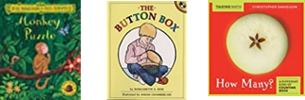  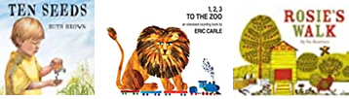  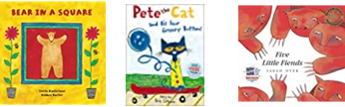  Additional information and resources can be found using the link below:  Maths home learning | Home learning | White Rose Maths |  | Reading Comprehension  This term the children will be introduced to our daily ‘Pledge’ story time session. During this story time they will listen to one of our Super 6 books. The children will vote each morning during self-registration for the book that they would like to hear.  Through the ‘Super 6’ texts, the children are able to listen to stories to build a familiarity and understanding, joining in with repeated phrases and rhyming words. The children will be encouraged to use these familiar texts to retell stories using key repeated language and vocabulary.  The children will be introduced to our weekly text based ‘Wow Words’ these words encourage the acquisition of new vocabulary.    At home you may wish to encourage your child to tell you about the Super 6 text that they listened to during Pledge time today. These stories will become more familiar each week. | Word Reading  From very early in the term the children will participate in daily phonics sessions. In addition to this they will also be reading their ‘Little Wandle’ phonics reading book three times a week during group reads. During the group read sessions the children will work on decoding, prosody and comprehension skills. The children will then take this book home to reread, building their confidence in word reading, fluency and understanding.  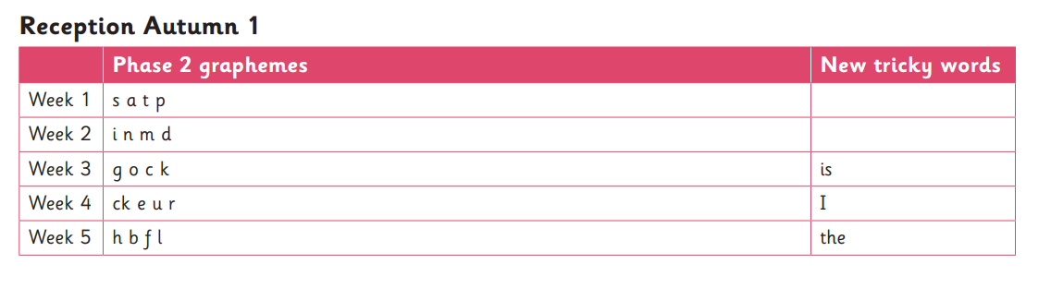  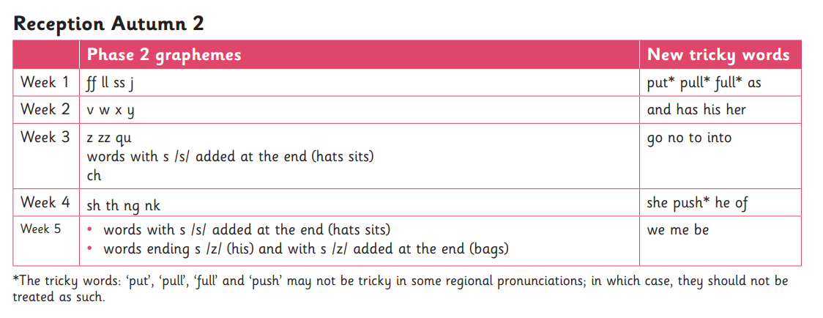  Each week the children will bring home a weekly phonics home learning sheet which provides additional information as to which sounds and tricky words the children have learnt during the week.  Please remember to listen to your child read their phonics book at home, it really does make all the difference to their reading journey and their confidence.  Some tricky word songs to watch at home:  https://youtu.be/TvMyssfAUx0  https://youtu.be/e2dx65u59aw
Writing  This term the children will be encouraged to freely use mark making as a tool for communication, ascribing meaning to the marks they make. They will participate in writing ‘challenges’ that are linked to the weeks focus text.  As the children learn sounds at a rapid pace during their phonics lessons, they will be encouraged to communicate using recognisable letters.  After a few weeks the children will begin to segment words into sounds and record these using the corresponding letters.  A great way to encourage your child to write at home is to involve them in writing your shopping lists, birthday cards, labelling their toys and pictures.  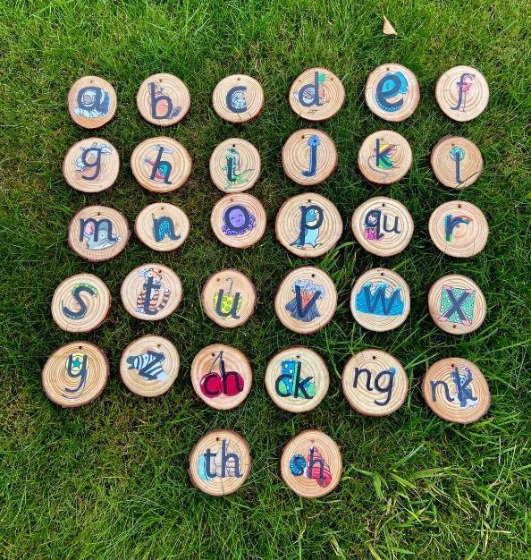 |  | Knowledge and Understanding of the World  This topic will focus on the childrens families, friends, their appearance, likes and dislikes. They will create portraits, models and representations of themselves and the people who are important to them.  We will be looking at the book ‘Junk DNA’ and using some similar resources to create portraits.  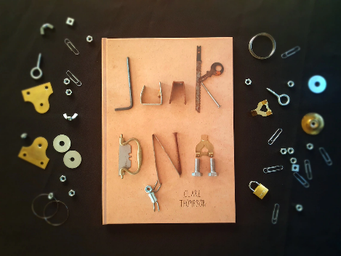  The children will be encouraged to talk about significant events in their lives; when they were a baby, a toddler and now. They will look at how much they have changed and grown.  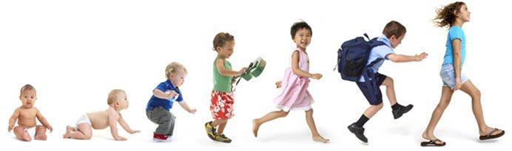 | Expressive Arts & Design  The children will be taught how to use the powder paints. They will learn how to colour mix primary and secondary colours.  Water ~ Sponge ~ Paint ~ Mix  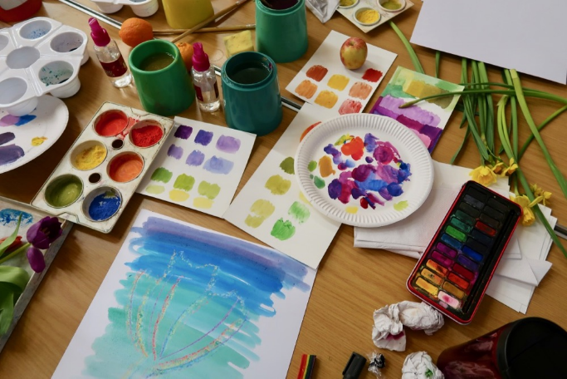  We will be encouraging the children to use props and small world items, in their learning, to retell given narratives or roles.  