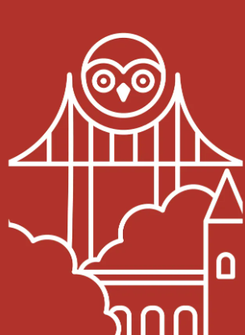 | Year 5/6 Autumn Term  Ancient Greeks |  |  |  | Book cover  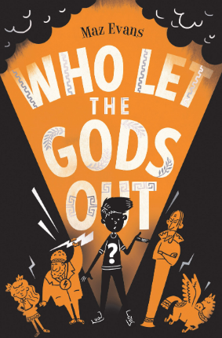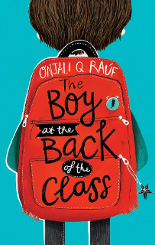
Maths  This term, both Year 5 and Year 6 will be focusing on place value, addition and subtraction, multiplication and division and fractions. This is in order to build on basic mathematical concepts. |  | Reading  In Reading, we will be developing key skills through our lead texts “Who Let the Gods Out” and “The Boy at the Back of the Class”. These novels incorporate our theme/topic for this term. |  | Science  This term we will be focusing on ‘Light’ and then ‘Animals including Humans’.
History  As historians, we will be looking at developing our questioning, asking historically valid questions about similarities and differences. We will also be looking at the impact that ancient civilizations (Ancient Greeks) had on society. |  | Geography  In Geography, we will look at the countries within Europe, latitude and longitude, exports and produce, building on prior knowledge whilst comparing Greece to Britain. |  | Art & Design  During our art block, we will study artist Kurt Schwitters and his techniques of collage. During our DT block, our focus will be on digital technology, looking at monitoring systems for animals.
RE  We will focus on our topic of “Expressions” and how different religions express their faiths. |  | PSHME  This term we will look at ‘Being Me in my Own World’, thinking about personal responsibilities within school and our communities. Then, we will study ‘Celebrating Difference’, understanding conflict and differing opinions. |  | Writing  In Writing this term, the children will be deconstructing, planning and writing across a range of genres.  In the first half-term, we will be writing narrative texts and instructions based upon our Pledge text: ‘Who Let the Gods Out’  After half-term, we will be writing persuasive letters based upon ‘The Boy at the Back of the Class” and Christmas narratives based upon “The Miracle of Ebenezer Street”.
PE  This term, we will begin by looking at Football, understanding the progressive skills required. | Computing  In computing we will be looking at the history of computers. We will also be exploring the different parts of a computer and there functions. | Music  All the learning is focused around one song: Make You Feel My Love. The material presents an integrated approach to music where games, elements of music (pulse, rhythm, pitch etc), singing and playing instruments are all linked. As well as learning to sing, play, improvise and compose with this song, children will listen and appraise other Pop Ballads. | Languages  French transport and “in my French house” | Global Awareness/British Values  This is taught through our themes during daily worship. | RSE  N/A
Useful websites:

https://ttrockstars.com/ [using logins provided]

https://whiterosemaths.com/parent-resources

https://www.bbc.co.uk/bitesize/primary

